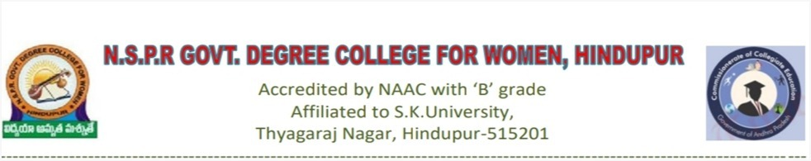

**Program Outcomes of Mathematics Combination Groups**

**1 M.P.C.:**

* Using appropriate mathematical concepts and skills students can demonstrate an understanding of principles and theories of Physics and Chemistry Develop the knowledge , skills and attitude necessary to pursue further studies in Mathematics and research in Mathematics Use appropriate mathematical concepts and skills to solve problems in both familiar and unfamiliar situations including those in real life context and completely world in getting jobs.

**2 M.P.Cs**:

* Understand the concepts of vector spaces, group theory, quantum mechanics, optical, thermal, electrical, mechanical properties of a materials, probability, algorithm design, data base design, web design. Develop the knowledge , skills and attitude necessary to pursue further studies in Mathematics and research in Mathematics Use appropriate mathematical concepts and skills to solve problems in both familiar and unfamiliar situations including those in real life context and completely world in getting jobs Analyse the concepts of mathematics, physics and computers science able to relate them in numerical programming of models of physical systems.

**3 M .S.Cs** :

* Understand the concepts of vector spaces, group theory, probability, distributions, sampling techniques, algorithm design, data base design and web design. Analyse the concepts of mathematics, statistics and computers science able to use them in algorithm design and data science. Use appropriate mathematical concepts and skills to solve problems in both familiar and unfamiliar situations including those in real life context and completely world in getting jobs real life context and Develop the knowledge , skills and attitude necessary to pursue completely world in getting jobs further studies in Mathematics and research in Mathematics.